🔢 Arduino DIY Calculator using 4x4 Keypad & 16x2 LCD 📟

🚀 Overview
This is a simple yet functional calculator built using an Arduino Uno, a 4x4 Keypad, and a 16x2 LCD Display. It can perform basic arithmetic operations (+, -, *, /), supports decimal numbers, and includes error handling for invalid inputs (like division by zero).

🛠 Features
✅ Basic Arithmetic Operations → Addition, Subtraction, Multiplication, Division
✅ Decimal Support → Perform calculations with decimal numbers
✅ Error Handling → Prevents multiple operators, division by zero errors
✅ Clear Functionality → Reset calculations with a single press

📜 Components Required
Component | Quantity
Arduino Uno | 1
16x2 LCD Display (with or without I2C) | 1
4x4 Keypad | 1
10KΩ Potentiometer (for LCD contrast) | 1
Jumper Wires | Multiple
Breadboard | 1

🔌 Wiring Diagram
LCD Pins → Arduino Pins
VSS → GND
VDD → 5V
V0 → Middle Pin of Potentiometer
RS → 13
RW → GND
E → 12
D4 → 11
D5 → 10
D6 → 9
D7 → 8
A (LED) → 5V
K (LED) → GND

Keypad Pins → Arduino Pins
Row 1 (R1) → 7
Row 2 (R2) → 6
Row 3 (R3) → 5
Row 4 (R4) → 4
Col 1 (C1) → 3
Col 2 (C2) → 2
Col 3 (C3) → 1
Col 4 (C4) → 0

💻 Arduino Code
#include <LiquidCrystal.h>
#include <Keypad.h>

LiquidCrystal lcd(13, 12, 11, 10, 9, 8);

float first = 0, second = 0, total = 0;
char customKey;
bool isSecondNum = false;
char operation = '\0';

const byte ROWS = 4;
const byte COLS = 4;
char keys[ROWS][COLS] = {
{'1','2','3','/'},
{'4','5','6','*'},
{'7','8','9','-'},
{'C','0','=','+'}
};
byte rowPins[ROWS] = {7 ,6 ,5 ,4};
byte colPins[COLS] = {3, 2, 1, 0};

Keypad customKeypad = Keypad(makeKeymap(keys), rowPins, colPins, ROWS, COLS);

void setup() {
lcd.begin(16, 2);
lcd.print("Arduino Calculator");
delay(2000);
lcd.clear();
}

void loop() {
customKey = customKeypad.getKey();

if (customKey) {
if ((customKey >= '0' && customKey <= '9') || customKey == '.') {
if (isSecondNum) {
second = (second * 10) + (customKey - '0');
} else {
first = (first * 10) + (customKey - '0');
}
lcd.print(customKey);
}
else if (customKey == '+' || customKey == '-' || customKey == '*' || customKey == '/') {
if (operation == '\0' && first != 0) {
operation = customKey;
isSecondNum = true;
lcd.print(customKey);
}
}
else if (customKey == '=') {
if (operation != '\0' && isSecondNum) {
switch (operation) {
case '+': total = first + second; break;
case '-': total = first - second; break;
case '*': total = first * second; break;
case '/':
if (second == 0) {
lcd.clear();
lcd.print("Err: Div by 0");
delay(2000);
resetCalculator();
return;
} else {
total = first / second;
}
break;
}

lcd.setCursor(0, 1);
lcd.print("= ");
lcd.print(total);
delay(3000);
resetCalculator();
}
}
else if (customKey == 'C') {
resetCalculator();
}
}
}

void resetCalculator() {
first = second = total = 0;
isSecondNum = false;
operation = '\0';
lcd.clear();
}

📷 Project Preview
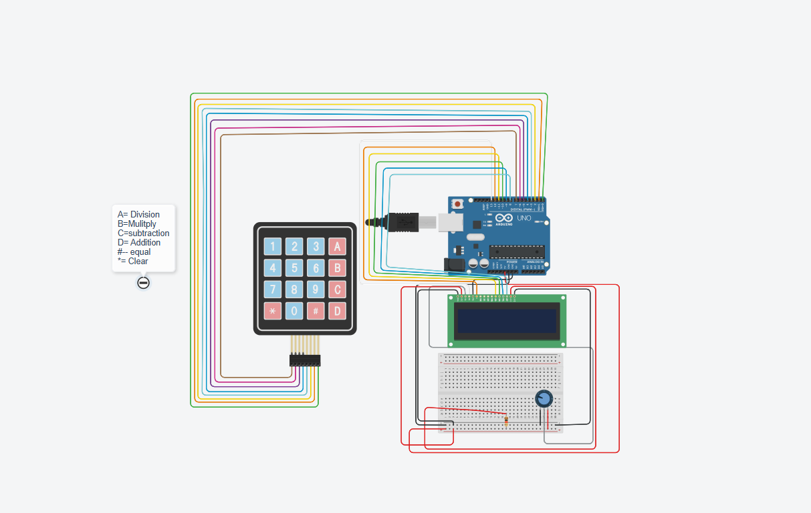

📌 How to Use?
1️⃣ Power up the Arduino.
2️⃣ The LCD will display "Arduino Calculator".
3️⃣ Press numeric keys to input numbers.
4️⃣ Press +, -, *, or / to choose an operation.
5️⃣ Enter the second number and press = to see the result.
6️⃣ Press C to clear and start a new calculation.

📚 Libraries Used
📌 Keypad.h - Used for handling the 4x4 keypad.
📌 LiquidCrystal.h - Used to control the 16x2 LCD Display.

📜 License
📝 This project is open-source under the MIT License. Feel free to modify and improve!

